Internal Capital Adequacy Assessment Process

2020

Ekspres Bank Group

(BNP Paribas Group)

EKSPRES BANK |  | EKSPRES BANK GROUP (hereafter Ekspres Bank)
ICAAP SCOPE |  | GROUP  Covering Ekspres Bank A/S, Ekspress Bank NUF and Express Bank Sverige Filial
SUPERVISOR | : | Danish FSA - Finanstilsynet
REFERENCE PERIOD | : | 31 December 2020
DOCUMENT HISTORY
STATUS | : | Final
LAST UPDATE | : | 31 December 2020
COORDINATED BY | : | EB Finance
PREPARED BY | : | EB Finance, EB Risk, EB Compliance  With the support of BNP Paribas Head-Office teams
REVIEWED BY | : | LOCAL VALIDATOR(S)  BNP Paribas Head-Office teams:  - Group Finance / Supervisory Affairs  - Finance Management

I. Executive Summary

1.1 Objective of the ICAAP

The objective of this document is to present a detailed view of the Ekspres Bank Internal Capital Adequacy Assessment Process (ICAAP) for 2021 based on 31 December 2020 data, in accordance with the guidelines from European Banking Authority (EBA) and the guidelines issued by the Danish Financial Supervisory Authority (FSA).

The aim of the ICAAP is to assess the adequacy of the capital held by Ekspres Bank given the risks borne based on an internal assessment of these risks. The process is conducted on Ekspres Bank prudential banking perimeter.

The ICAAP is addressed to Ekspres Bank Management, the Bank´s Board of Directors and to the Danish FSA.

Scope

The ICAAP process covers the three entities of Ekspres Bank:

- Ekspres Bank A/S
- Ekspress Bank NUF
- Express Bank Sverige Filial

BNP Paribas Personal Finance owns 100% of shares of Ekspres Bank.

Ekspres Bank belongs to Retail Banking & Services division and International Financial Services (IFS) sub-division of BNP Paribas Group organisation.

Purpose

This report considers BNP Paribas internal guidance on Capital Adequacy Assessment, which are promoted and fully applicable to its entities. This guidance is updated every year to consider all BNP Paribas supervisors feedback.

This report also answers to the request of fulfilling the Duty of Disclosure set out in the Annex 2 to the Danish Executive Order on Capital Adequacy; cf. Executive Order no. 2155 of 03 December 2020 and the Danish Financial Business Act FIL.

1.2 Risk Identification

As a prerequisite to the ICAAP, Ekspres Bank has implemented a comprehensive risk identification process. In particular, based on its own assessment, the following categories of risk are considered as material by Ekspres Bank:

- Risk types defined by the Basel regulation – Pillar 1 risks – namely credit risk, market risk, and operational risk;
- Risk types identified through the Ekspres Bank risk identification process and captured in the internal risk taxonomy – Pillar 2 risks –credit risk, risk related to growth in business volume, interest rate risk, liquidity risk, operational risk etc.

For each of the aforementioned risk types, the section IV. Internal Capital requirement assessment and aggregation presents the underlying risk strategy and management processes of Ekspres Bank, and presents in this context, Ekspres Bank’s assessment of the sufficiency of Pillar 1 and Pillar 2 capital requirements.

1.3 Capital adequacy assessment

Ekspres Bank’s overall Internal Capital Adequacy Assessment framework is structured around the following components:

1.3.1 A regulatory capital framework

Ekspres Bank has implemented “Guideline on Adequate Capital Base and Solvency Needs for Credit Institutions” issued by the Danish FSA. Ekspres Bank is using the solvency need model published by the Association for banks in Denmark “Lokale Pengeinstitutter”, and wants to remain compliant at all time with regulatory expectations at a given reporting date as well as with a forward-looking perspective, i.e. sustaining its strategy. This regulatory compliance objective represents as such a key consideration for capital adequacy assessment purposes.

Summary of regulatory capital & solvency ratios - Ekspres Bank A/S

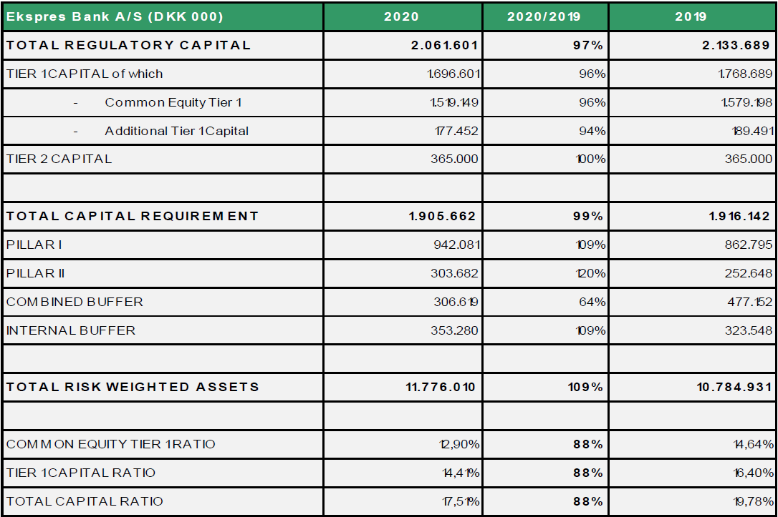

Reminder:
- The minimum Common Equity ratio is 4,5%
- The minimum Tier 1 ratio is 6%
- The minimum total capital ratio is 8%
- The Capital Conservation Buffer is 2,5%
- The current Countercyclical capital buffer is 0,1%; Denmark is 0%, Norway 1% and Sweden 0%.

The assessment conducted by Ekspres Bank reached the conclusion that:
- Ekspres Bank holds sufficient regulatory capital to comply with its regulatory capital expectations, including the CET1 ratio constraint arising from the Pillar 2 capital requirements decision. (12,90% as at 31 December 2020) and the total capital ratio constraint.
- Ekspres Bank holds sufficient capital to cover its risks evaluated through the 8+ methodology.

1.3.2 An internal capital analysis, the 8+ methodology

In accordance with the Guidelines issued by the Danish FSA (VEJ no. 10009 of 17. December 2020), Ekspres Bank has adopted the required 8+ methodology for assessing the capital adequacy. The 8+ methodology assumes that all normal risks are covered by the Pillar 1 requirement of 8%. In addition banks are required to assess to what extent they have additional risks and the necessity of an additional capital requirement (Pillar 2). The Danish FSA has issued guidance on the calculation methods to be applied when quantifying the Pillar 2 risks. The 8+ methodology is applied and reported for Ekspres Bank A/S.
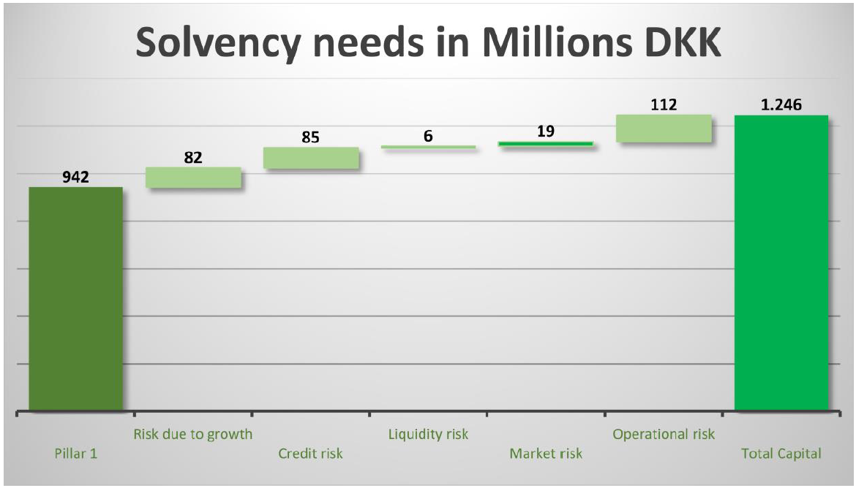

This confirms that, as of 31 December 2020, Ekspres Bank was adequately capitalised.

Ekspres Bank has received a SREP letter in 2020 with the following comment from the ECB: “Taking into consideration the conclusions set out in paragraph 3.11, Ekspres Bank A/S shall meet, on an individual basis, a TSCR of 10.20% (which includes a Pillar 2 additional own funds requirement of 2.20%)”.

1.3.3 A forward looking assessment of the regulatory capital planning

In addition to the assessment of the capital adequacy as at 31 December 2020, Ekspres Bank also performs, as part of its ICAAP, an assessment of its capacity to sustain its strategy and respect the regulatory requirements on an ongoing basis over a 3 years horizon.

These forward-looking requirements delineate the minimum acceptable level for Ekspres Banks capital trajectory and are key inputs in the capital planning process.

The projection of Ekspres Bank CET1 ratio estimated in the course of the budget process over a 3-year time horizon allows the entity to conclude on its ability to respect this supervisory requirement of CET1 on an ongoing basis.

Ekspres Bank CET1 ratio planned trajectory

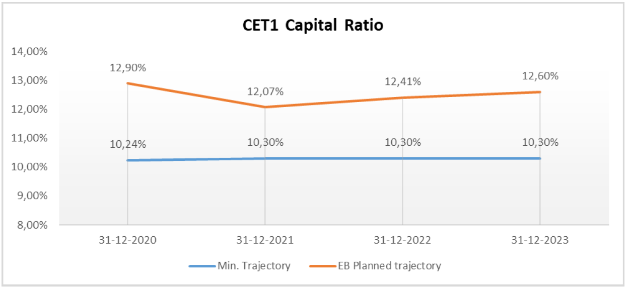

1.4 Gearing (Leverage ratio)
Gearing refers to the core capital as a percentage of the banks total exposures. There is currently no legal requirement for maximum gearing. However from June 2021 a gearing requirement of 3% have been issued by the Basel committee, equal to a maximum gearing of the core capital times 33. FSA states that for non SIFI-bank in which the gearing is above 7% the bank does not need to elaborate on the gearing risk.

At the end of 2020 the gearing factor is calculated to 12%, which is above the threshold for gearing to be considered a risk, thus the bank have not included an add-on in the solvency requirement calculation to cover gearing risks.

1.4 Conclusions as approved by appropriate governance

Ekspres Bank’s ICAAP relies on a close risk-by-risk monitoring of capital adequacy, within the regulatory perspective and the internal perspective, in actual and forward-looking views. The 2021 ICAAP (based on 31 December 2020 data) concludes that Ekspres Bank is adequately capitalised both within the regulatory and the internal perspectives, and that no additional capital is needed above the already calculated regulatory capital requirement.

Furthermore, Ekspres Banks ICAAP concludes that considering the strength of the business model and the strict risk culture developed across the whole BNP Paribas Group, Ekspres Bank is adequately capitalised and is in a capacity to sustain its strategy.

In addition, the BNP Paribas Group has a general and long-lasting policy to ensure that its subsidiaries, and among them Ekspres Bank, have the necessary capital resources to meet their local regulatory requirements.

